

didactics.co.in

**Application Work Flow**

*(This section displays the flow of information in the application)*

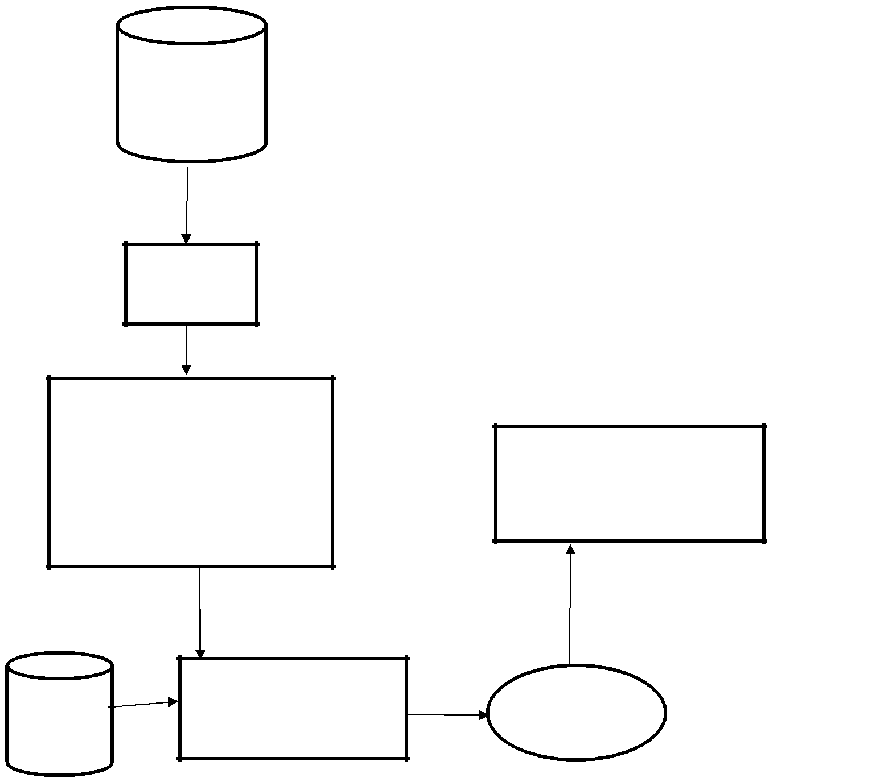

Training Data

Data

Cleaning

Training Data

k-NN

Regression

Naïve Bayes

Decision Tree

Evaluate

|  |  |  |  |
| --- | --- | --- | --- |
|  | Machine Learning | Prediction |  |
| Test Data | Algorithm |  |
|  |  |



www.didactics.co.in